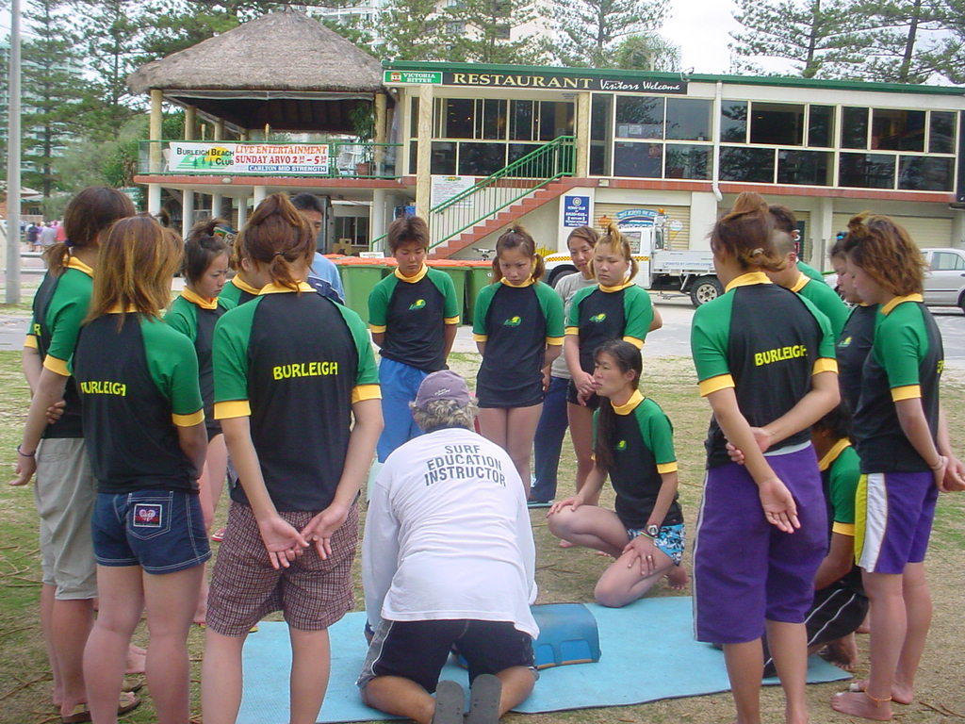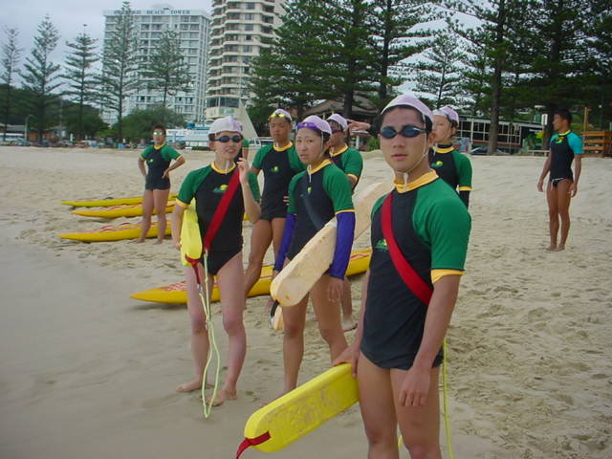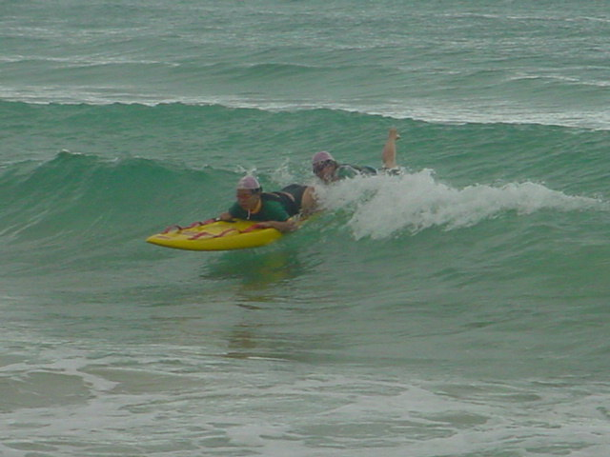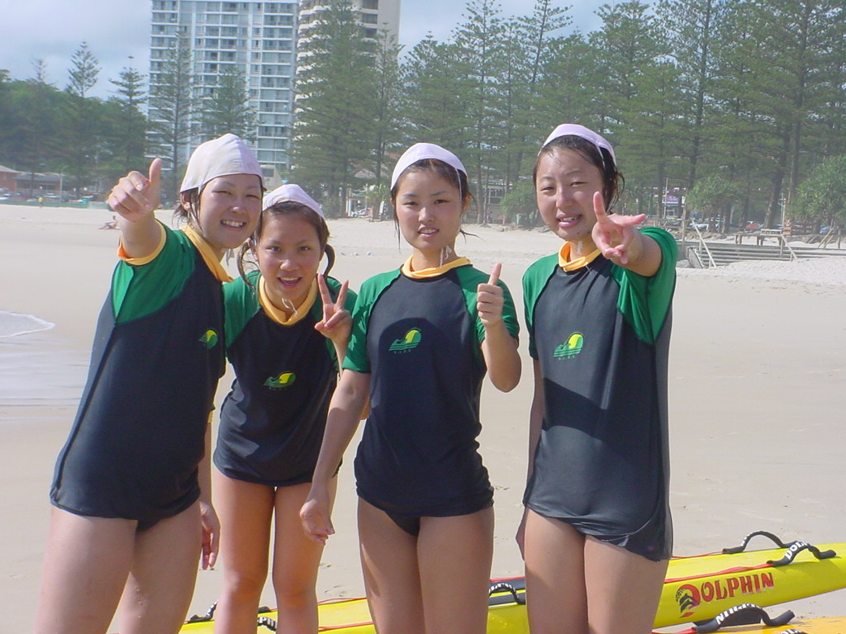

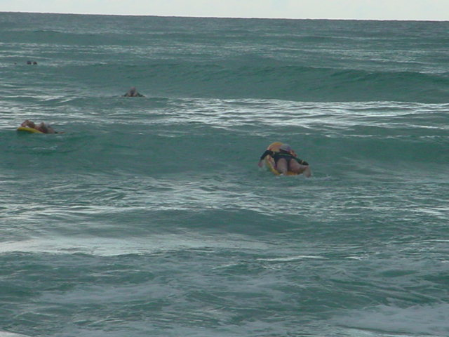
Oz E International Surf lifesaving, Diving and
English Language Tours

Tour |  | Description | Included | Length | Date |  | Price
Bronze medallion surf lifesaving |  | Earn your bronze medallion in surf lifesaving and resuscitation. This challenging 50 hour course is held on the beautiful beaches of Burleigh Heads. | Training and materials, transport, share accommodation in self–contained units, celebration bbq and farewell dinner. | 12 days | 31 Jan 2004 –  11 Feb 2004 |  | AUS $1600*
Stradbroke Scuba diving |  | Take the chance to see turtles, sharks, dolphins and manta rays with a reputable dive company in the open waters off Stradbroke Island. | Three double dives and equipment, three restaurant meals per day, transport, share accommodation, farewell dinner. | 7 days | 10 Feb 2004 –  16 Feb 2004 |  | AUS $1460*#
Bronze medallion surf lifesaving and Stradbroke Scuba Diving |  | Experience surf lifesaving and diving. It’s a fabulous opportunity to make the most of a visit to Australia. | Training and materials, transport, share accommodation in self–contained units, three double dives and equipment, three restaurant meals per day, celebration bbq and farewell dinner. | 17 days | 31 Jan 2004 –  16 Feb 2004 |  | AUS $2775*#
Bronze medallion surf lifesaving | Individual private course |  | Training and materials, one way airport transfer to Burleigh Heads | As requested | As requested | AUS $760
English language study tour |  | Practical English lessons delivered by highly qualified teachers. This tour allows students to study and practice their English as well as enjoy beautiful Brisbane and its surrounds. | 21 hours of quality English language tuition, 7 afternoon excursions, 3 full day excursions, homestay accommodation and 3 meals per day. | 16 days | 29 June 2003 –  14 July 2003  and  01 Feb 2004 –  16 Feb 2004 |  | AUS $1835**

*GST included. Based on 15 person minimum in low season.
** GST included. Based on 12 person minimum.
# Participants need to have their open water dive card prior to joining the tour.
Surf survival, surf awareness and pool life guard courses are also available as well as training for juniors and nippers.

- Bookings are taken for smaller groups to complete surf lifesaving and diving tours. Please inquire for a quote.
- If your group has the minimum number of people required, you can request a private tour at a date that suits you. Please note that accommodation prices are subject to change due to holiday seasons. Tours can be altered at the group’s request. Alterations may lead to a change in price.
- No FOC’s are given for leaders accompanying a group to Australia.
- Oz E International also offers other English language and sporting programs.
- All tours are fully supervised.
- Oz E International welcomes the opportunity to provide you with further information on any of the above mentioned tours. Please contact us with your request at info@ozeinternational.com .

